Chapter 14 Vocab

1. Art Nouveau - Kimberly Tesam Moita

Art Nouveau was an attempt by artists and artisans to develop a style with no roots in earlier artistic forms. It was designed with emphasized sinuous curved lines, contorted and stylized forms from nature, and a constant sense of movement. (pg. 384) It was used in architecture, clothing, art, patterns, and fabrics of the times. Most silhouettes of dresses from the 20th century followed these lines, and the forms and the designs of art nouveau showed up in fashion by way of embroidered patterns, fabric prints, stylelines, and beading. By 1914, and with the beginning of the WW1, Art Nouveau was exhausted. In the 1920s, it was replaced as the dominant architectural and decorative art style by Art Deco (Wikipedia) (These lithographs were colored and the art is by Mary Golay who was an artist during this period who specialized in colored lithographs.)

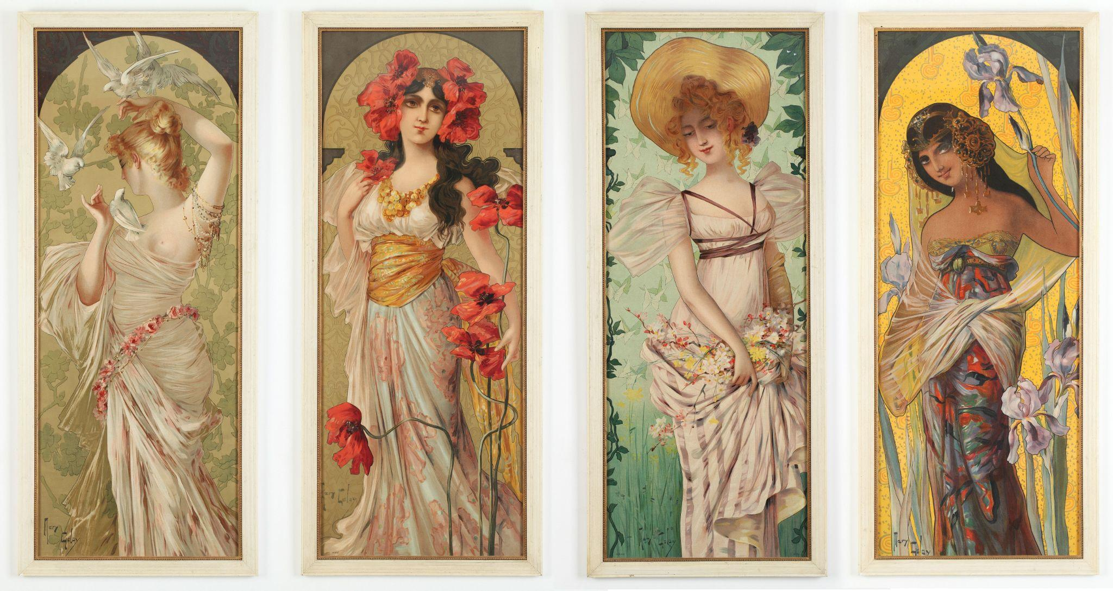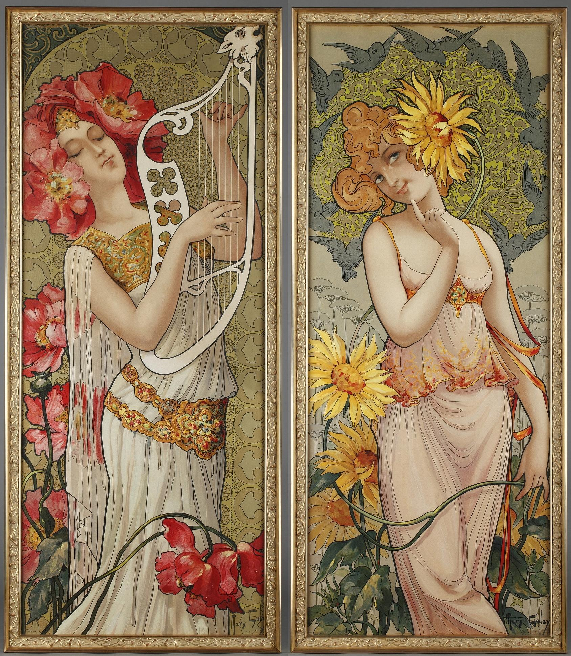

<https://en.wikipedia.org/wiki/Art_Nouveau>

<https://www.theartstory.org/movement/art-nouveau/history-and-concepts/>

<https://www.britannica.com/art/Art-Nouveau>

1. Boa - Aubrey Reidhead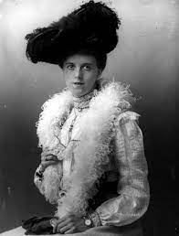

In the nineteenth century, the boa was a scarf accessory. It was a long scarf of feathers or fur that was tubular (pg. 402). The boa used to be a symbol of wealth and was theatrical. The boa goes in and out of style, but whenever it makes a come back it is stunning. ([Grazia](https://graziamagazine.com/us/articles/feather-boa-history/)) Ostrich, marabou, chandelle, and turkey are the most commonly used feathers, so hopefully, you don’t have an allergy to any. These are light but come in all different fluffiness densities ([Wiki](https://en.wikipedia.org/wiki/Feather_boa)).

Survey of Historic Costume 6th edition

1. Bust bodice: Madison Frost

A bust bodice was typically made of cotton. It has a slightly pointed neckline and short sleeves. It typically goes right below the bust length. There is usually a bow that will tie in the back. This provides extra support for the bust. There are specific seams over the bust to provide extra support and shape.

<https://collections.vam.ac.uk/item/O316198/bust-bodice-unknown/>

Book

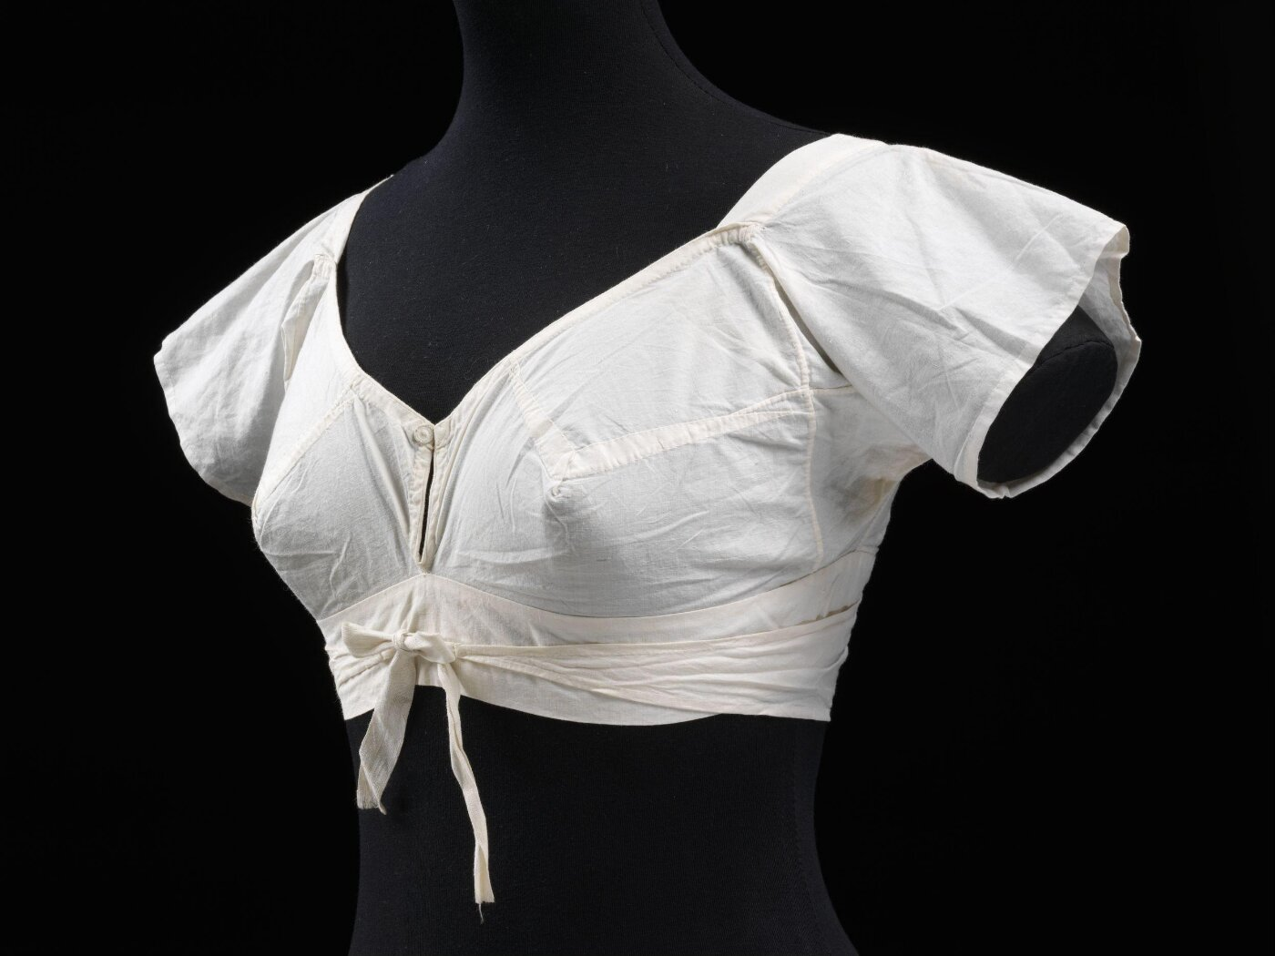

1. Bust improvers- Bailey Pinder

Bust improvers were worn to fill out a “deficient figure”. They were meant to create the ideal figure and support the bust. They were made of flexible celluloid and other fabric and stuffed with pads of cotton. They could be worn on top or underneath the corset.

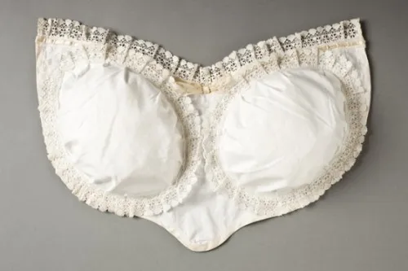

<https://ateliernostalgia.wordpress.com/tag/bust-improver/>

<https://redthreaded.com/blogs/redthreaded/what-the-heck-is-a-bust-bodice>

Survey of Historic Costume, pg 397

1. Bustle - Debbi Wright

In our textbook we learn that there were three subdivisions of the Bustle Period 1870-1890. At the beginning the bustle was supported by the cage crinoline. Other crinolines were created by adding cushions to half hoops of steel.

These outfits were made of two pieces, the bodice and skirt.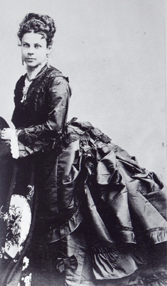

1870-1878: full bustle created by manipulation of the drapery at the back of the skirt

1879-1883: sheath or cuirass bodice, fullness dropped to below the hips, half circle frame supported trailing skirts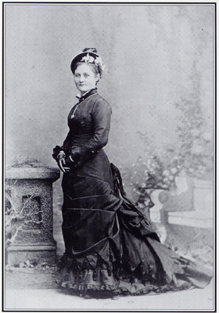

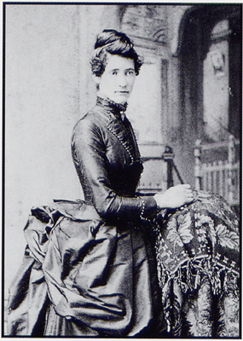1884-1890: large rigid shelf like bustles

Toratora, Phyllis G, and Keith Eubank. *Survey of Historic Costume, 5th Edition*. Berg, 2009

<https://lowelldesigns.com/bustle-late-victorian/>

<https://bellatory.com/fashion-industry/The-Bustle-Era-Womens-Fashions-of-the-1870s-1880s>

1. Camisole- Samantha Hooper

In the 1890’s, corset covers became known as camisoles. They smoothed the lines of the corset underneath the outergarments, as well as protecting the outergarments from the hardware in corsets.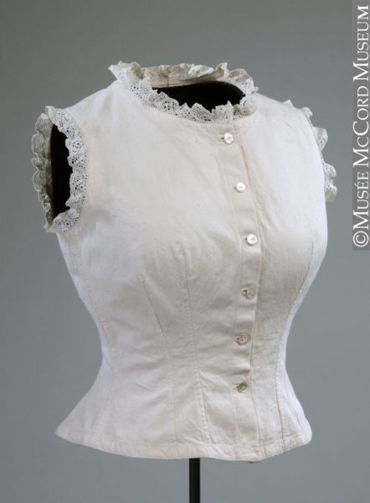

<https://trulyvictorian.info/index.php/product/tv107-mid-victorian-corset-covers-paper-pattern/>

<https://historicalsewing.com/corset-covers-chemisettes-under-bodices>

1. Combination (undergarment)- Ryann Becker

An undergarment that was a combination of a chemise and drawers into one garment. This made the undergarments much simpler and less bulky. Ladies then could wear dresses that fit more closely. The combination by 1890 had replaced the chemise. 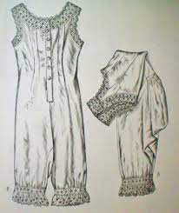

<http://fashioningnostalgia.blogspot.com/2013/08/victorianedwardian-combination-chemise.html>

<https://fidmmuseum.org/2010/10/combination-undergarments.html>

Textbook page 386

1. Cuirass Bodice: Abbie Burns

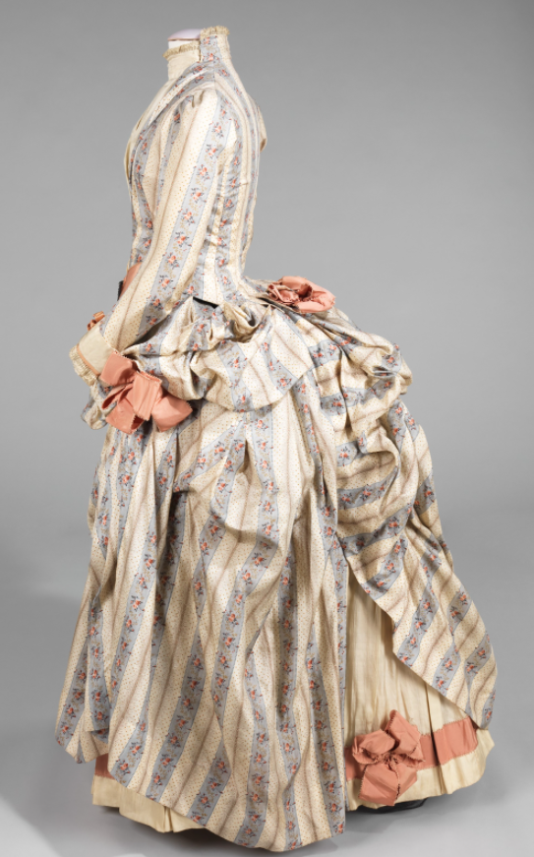

This style came about between 1878-1883, it was a more narrow bustle and was more full in the back and dropped below the hips and had a more semicircular frame with support from the trailing skirt. This bodice did replicate a piece of armor with its well boned structure and lace to make it look feminin. The reason this bodice is even considered armor was because it originated from the word “cuirass” which was armor that was close fitting worn over the chest or torso.

Sources: Book 386

<https://fashionhistory.fitnyc.edu/cuirass-bodice/>

<https://genealogylady.net/2015/09/20/fashion-moments-cuirasse-bodice/>

1. Deerstalker cap - Jensen Stenquist

This hat was made famous through the illustrations of Conan Doyle’s Sherlock Holmes stories. The deerstalker was a type of cap favored by deer hunters and other sportsmen in nineteenth-century [England](https://www.encyclopedia.com/places/britain-ireland-france-and-low-countries/british-and-irish-political-geography/england). Also called a "fore and aft," the deerstalker was distinguished by its front and back visors. Large exterior ear flaps could be tied on top or allowed to cover the ears for warmth. The cap was usually made of checked material, typically sportsman's tweed or cloth. The crown was lined with scarlet poplin and was reversible.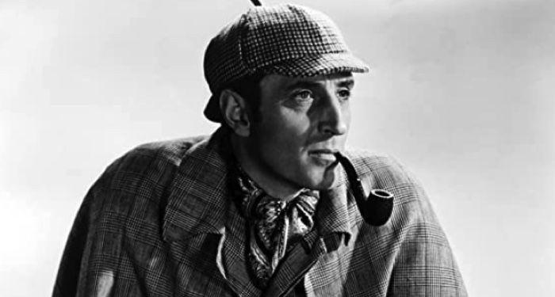

<http://www.fashionencyclopedia.com/fashion_costume_culture/European-Culture-19th-Century/Deerstalker-Cap.html#ixzz7M1eJqu69>

<https://www.encyclopedia.com/fashion/encyclopedias-almanacs-transcripts-and-maps/deerstalker-cap#:~:text=The%20deerstalker%20was%20a%20type,prominent%20feature%20of%20men's%20dress>.

Textbook Pg. 398, 403

1. Dinner jacket: Kya Boyd

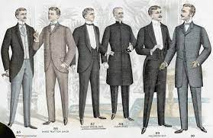

Invented in 1865 made by the same cloth as the evening gown Dinner jacket is cut like a tailcoat to help men move around more comfortably and made by the same cloth as evening clothes. Eventually the lounge jacket came indoors as a smoking jacket. The dinner hour is marked as the end of morning and beginning of evening formalities. Society was expected to change into the evening dress before dining to prepare for any function; afterwards the dinner jacket could not be seen prior to 7 or 8 evening meal.

Sources:

<https://kingandallen.co.uk/journal/2017/a-short-history-of-the-dinner-suit/>

<https://www.gentlemansgazette.com/tuxedo-black-tie-guide/black-tie-tuxedo-history/dinner-jacket-debut/>

“Survey of Historic Costume”

1. Fedora - Irelynd Preece 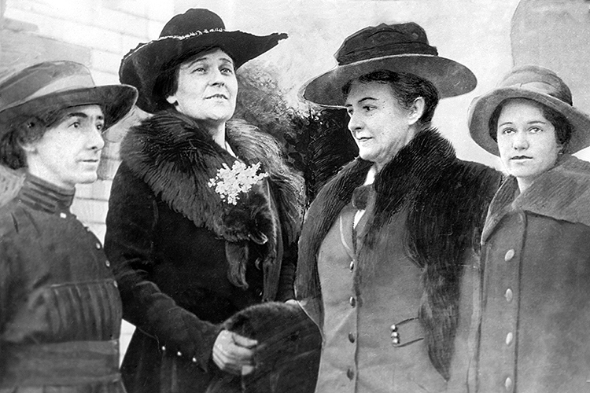

Fedoras were low, soft hats, with the crown creased front to back. Men and women both wore these hats, but in the book it tells us that women only wore them for sportswear or work. However, sources from the internet explain that the hat was very fashionable for women and the womens rights movement adopted it as a symbol. People also liked that the hat protected the wearers head from wind and weather. Fedoras were typically made out of wool or leather.

Textbook page 400 & 403

<https://www.metmuseum.org/art/collection/search/112760>

<https://en.wikipedia.org/wiki/Fedora>

1. Gibson Girl- Anna Ament

The Gibson Girl was the ideal feminine image for women in America during the early 1900s. It was based on illustrations made by Charles Gibson. Women used this image as inspiration for beauty and fashion. One of the main characteristics of the Gibson Girl was a very tiny, accentuated waist. More traits of this look included fluffy sleeves, big hats, and bouffant updo. At this time, women began to wear clothing that made motherhood and other responsibilities easier. Women's clothing became less extreme and more functional and realistic, enabling more independence. However, the waist look was still an important aspect of fashion, and corsets were used to achieve this look. Sass and confidence were also parts of the persona that was known as the Gibson Girl. It was more than just a style 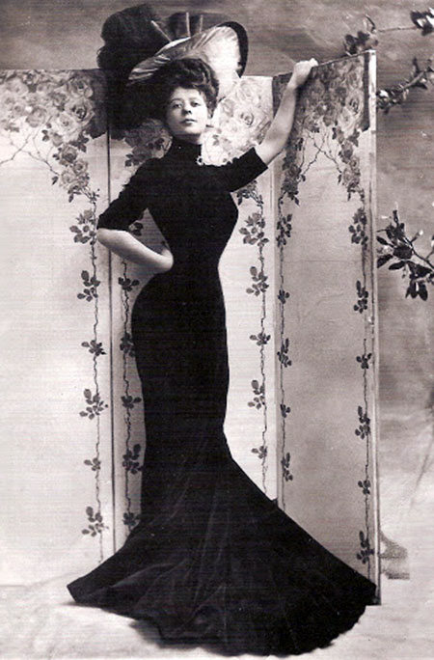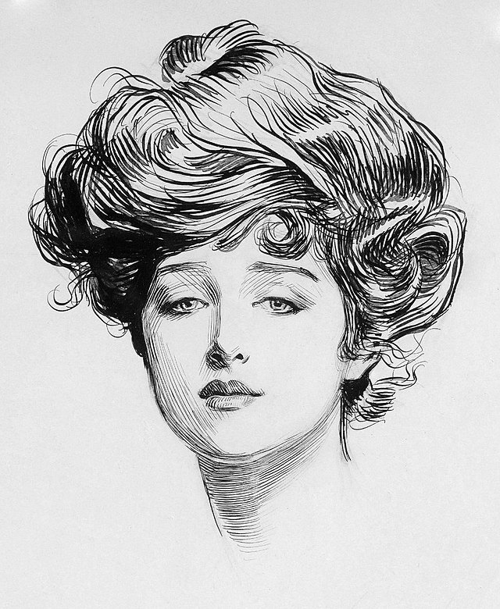

<http://www.eyewitnesstohistory.com/gibson.htm>

[(Links to an external site.)](http://www.eyewitnesstohistory.com/gibson.htm)

<https://www.thegracemuseum.org/online-learning-blog/2020/6/17/womens-fashion-evolution-from-gibson-girl-to-flapper>

1. Homburg - Alex Clark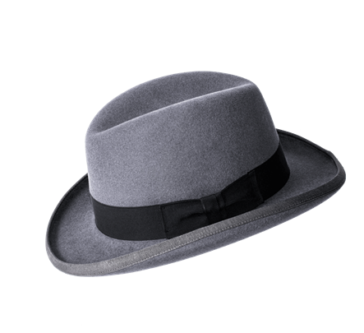

The homburg was another version of the fedora. It was a semi-formal hat typically made of felt and had a single dent down the middle of it with a type of ribbon wrapped around it as well. Homburg originally was a type of hunting hat.

Survey of Historic Costume, Page 403

<https://bellissimohats.com/blogs/resources/homburg-hat-guide>

<https://en.wikipedia.org/wiki/Homburg_hat>

<https://magillhats.com/product/homburg/>

1. Inverness Cape- Hailey Child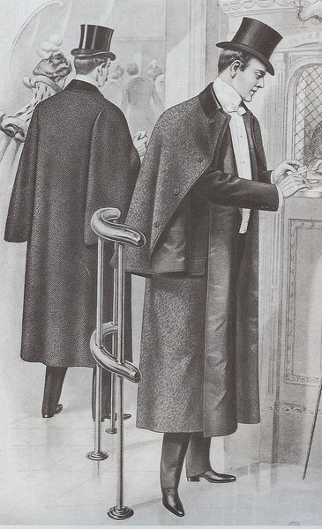

An Inverness cape is known to be a weatherproof outer-coat. More like a long cape, it is sleeveless with armholes below the cape. Made with two styles. One, more formal, is finished with short lapels, and the other with no lapels. Usually made of tweed, nylon or twill-weave fabrics.

<https://en.wikipedia.org/wiki/Inverness_cape>

Book

<https://fashionhistory.fitnyc.edu/1870-1879/>

1. Jersey - Savannah Jeppson

A predominant fabric used in sports costumes was a wool knit. It was adopted by a famous lady born in Jersey, named Lillie Langtry, for her tennis costume. She was nicknamed “the Jersey Lillie”, thus coining the fabric “jersey”, which is what it is still called today. Jersey knits are lightweight in comparison with other knits and are the fastest weft knit to produce.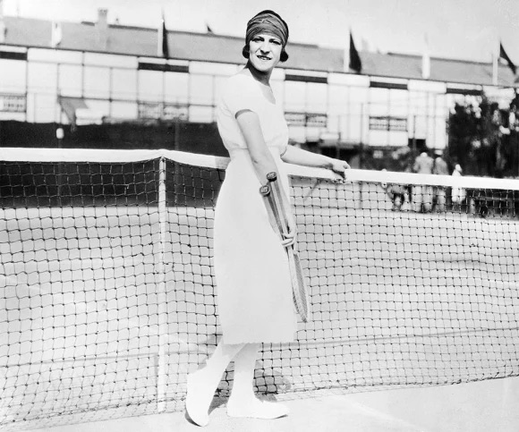

The Book: Survey of Historic Costume

<https://fashion-history.lovetoknow.com/fabrics-fibers/jersey-fabric>

<https://fromthebygone.wordpress.com/2017/04/29/vintage-photos-of-suzanne-lenglen-the-greatest-female-tennis-player-in-history/>

1. Knickers- Jessica Fraser

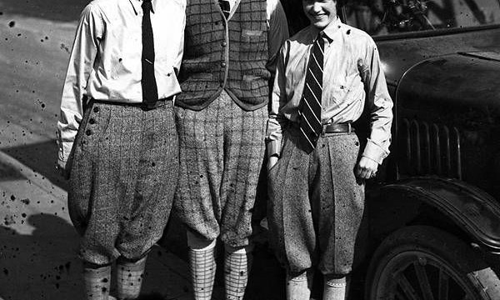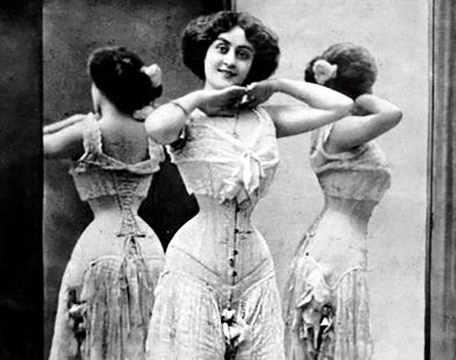

Knickers were boys' trousers that were long and baggy. They hit right below the knee and were tied down by a button. It was mens fashion for sports but later became something women wore as well. Now knickers were also known as women's undergarments around this same time period. It was still baggy around the legs but gave the women extra modesty and warmth. They would be covered in lace and bands.

Sources:

The Book

<https://fashionhistory.fitnyc.edu/knickerbockers/>

<https://localhistories.org/a-history-of-knickers/>

1. Kate Greenaway styles- Andrea Lazaro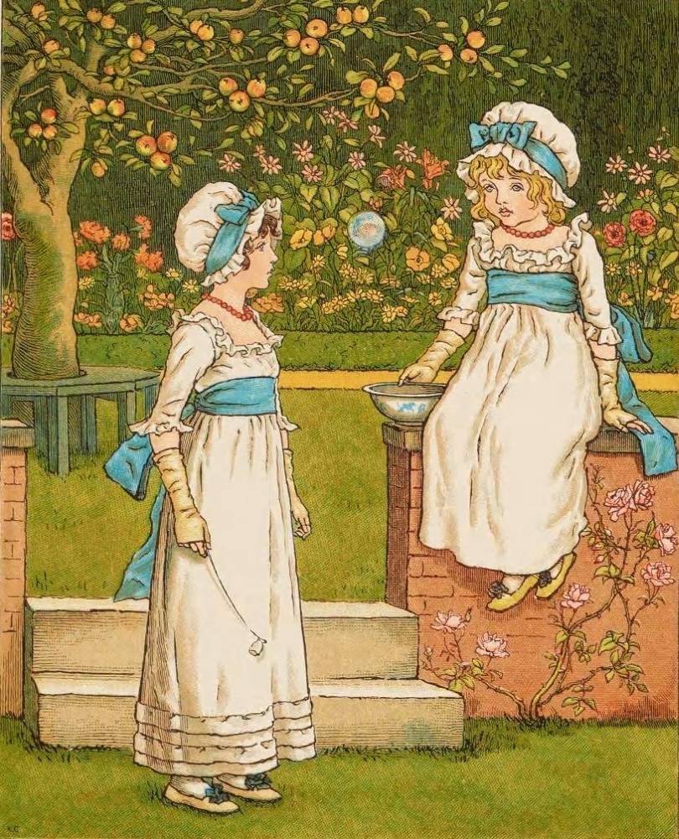

Kate Greenaway was a popular children’s book illustrator during the Golden Age (9th Century). Her work featured children as the main characters of her stories. Children were always depicted wearing ruffles, bonnets and other Empire styles, which reminded her of her own childhood. Kate received help from her mother by making clothes from children that also served as inspiration for her illustrations, and served as a source of inspiration for children’s fashion during the 19th Century.

Survey of Historic Costume page 404

<http://www.spacial-anomaly.com/kate-greenaway-nostalgic-children-illustrator-and-fashion-trendsetter/>

<https://societyillustrators.org/award-winners/kate-greenaway/>

1. Leg-o-mutton sleeves - Amanda Taylor

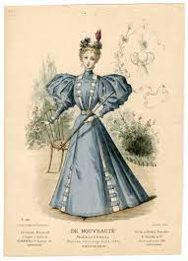

These sleeves had lots of fullness at the top that was either gathered or pleated and then would blend to fit at the wrist. These sleeves alone would use a yard or two of fabric. These were worn by both men and women but had some minor differences. This sleeve in French is called the gigot sleeve. The trend was fairly short-lived, ending when Queen Victoria took the throne.

<https://fashionhistory.fitnyc.edu/leg-of-mutton-sleeves/>

<https://www.anothermag.com/fashion-beauty/8295/a-brief-history-of-the-leg-of-mutton-sleeve>

Textbook Page 380

1. Little Lord Fauntleroy suit - Marisa Bone

The Little Lord Fantleroy suit was a velvet cut away jacket with matching knee pants, worn with a fancy blouse and a large lace or ruffled collar. They became popular right after the publication of Burnett's story in 1885 called Little Lord Fauntleroy. They became a major fashion trend for boys until after the turn of the 20th century. Calling someone a Little Lord Fauntleroy means to call someone an excessively polite and well dressed boy. 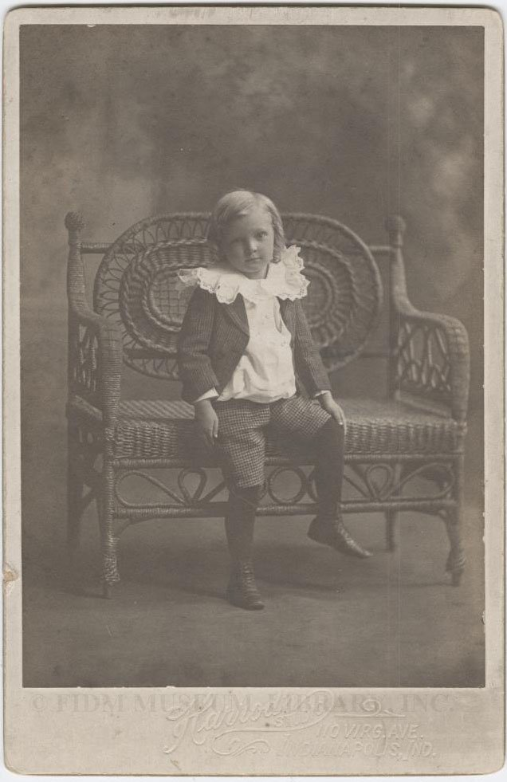

Sources [1](https://fidmmuseum.org/2009/09/little-lord-fauntleroy.html) and [2](https://en.wikipedia.org/wiki/Little_Lord_Fauntleroy)

Textbook page 387

1. Mourning crape- Brittany Pocock

This was something that they would wear to prove their sincerity when mourning someone. When a woman became a widow she was expected to be mourning for two and a half years. Crape was the kind of fabric used when making the mourning attire. A Crepe was the perfect attire for deep mourning because it didn’t reflect light which was custom during the deep mourning period. 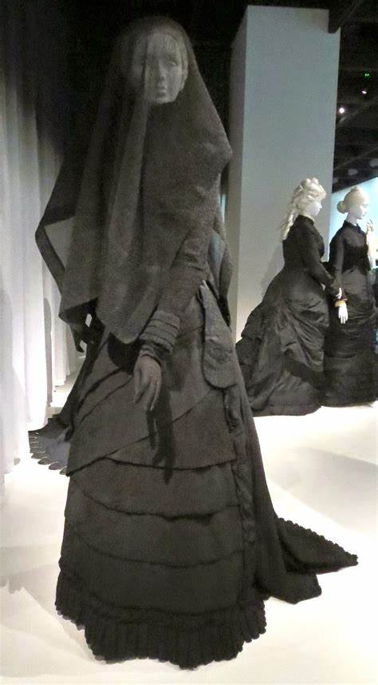

Book pg 411

[19th-Century Mourning Veils Were Made of a Cocktail of Poisons - Racked](https://www.racked.com/2018/3/29/17156818/19th-century-mourning-veil)

[What’s the Purpose of a Mourning Veil? | Cake Blog (joincake.com)](https://www.joincake.com/blog/mourning-veil/)

1. Norfolk jacket lena Kawakami

The prince of wales made the jacket popular, this jacket was a kind of sporty jacket and had box pleats, a belt in the front and pockets, it was a single breasted jacket and meant to be comfortable. It was used for activities like shooting and hunting. This jacket was the beginning of sports wear, today sports jackets and odd jackets are popular but they stemmed from this kind of jacket. <https://www.keikari.com/english/a-history-of-the-norfolk-jacket/> <https://www.gentlemansgazette.com/norfolk-jacket-guide/> 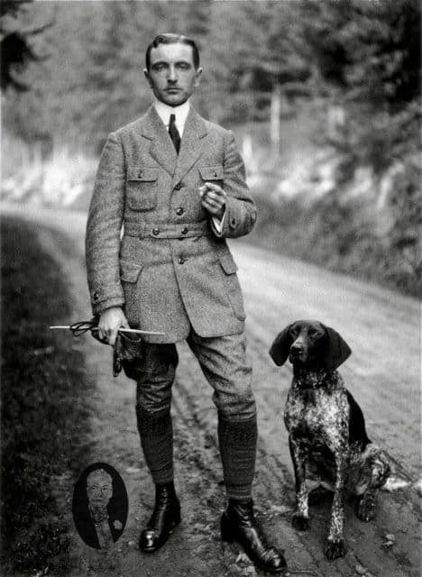

1. Princess Polonaise: Elizabeth Nathan

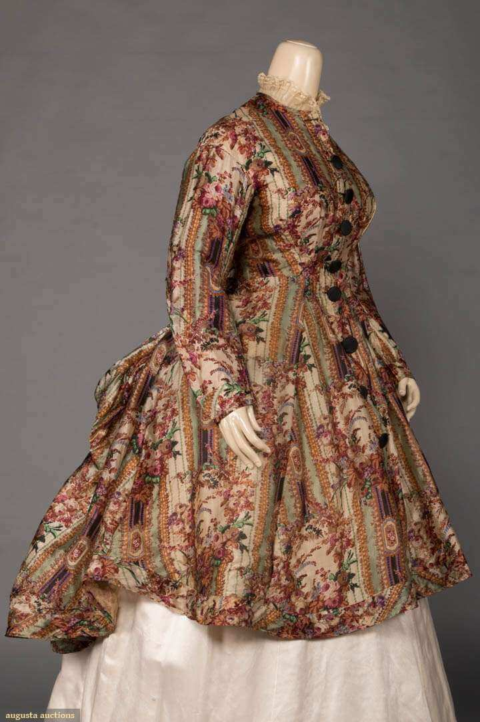

## A dress that is heavier on the back with a similar appearance to the Robe a la Polonaise. Polonaise style refers to the arrangement of the overskirt of a dress into three bunched swags to give the hips the impression of width and to display the petticoat underneath.Polonaise style featured ankle-length petticoats that revealed high-heeled walking shoes.

<https://fashionhistory.fitnyc.edu/polonaise/>

<https://en.wikipedia.org/wiki/Polonaise_(clothing)>

1. Rationals: Lexie Pincock

They are knickers. The term Rationals is used in England.

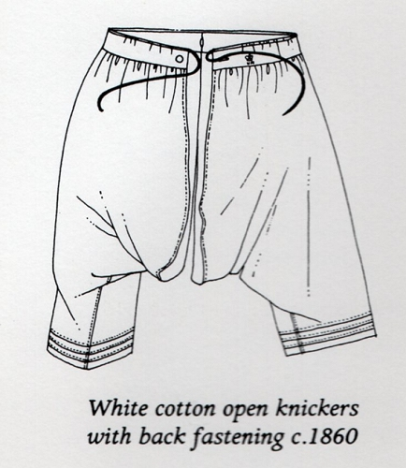

Sources:

Pg. 381

1. Ready-to-wear clothing -Jocelyn Munoz 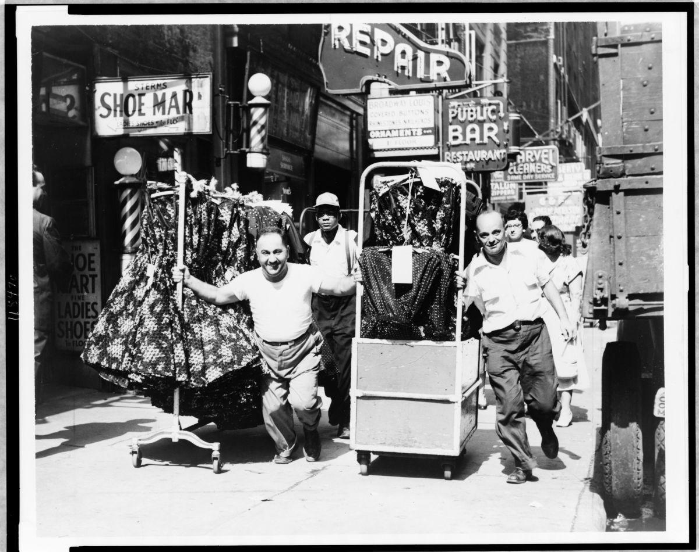

Ready-to-wear clothing is when an article of clothing is mass-manufactured in multiple sizes and sold in a finished condition, rather than being designed and made for one person. Ready-to-wear clothing has been around in some way shape or form since clothing began to be created. However ready-to-wear as we know it is still a fairly new development that began back in the 1800s, it first started during the war of 1812 but department stores helped popularize this around the 1860s, both in store and through mail-order catalogs.

<https://www.masterclass.com/articles/ready-to-wear-fashion-guide#:~:text=%E2%80%9CReady%2Dto%2Dwear%E2%80%9D,sewn%20for%20one%20particular%20person>.

<https://bellatory.com/fashion-industry/Ready-to-Wear-A-Short-History-of-the-Garment-Industry>

Tortora, P. G., & Marcketti, S. B. (2021). In Survey of historic costume. essay, Fairchild Books.

1. Shirtwaist blouse- Abigail Storrer

Shirtwaist blouses were, as the word describes, blouses for women. They were also called waists. These blouses were different in that they were a bit more masucline or designed similar to mens shirts. Though they could also still be very womanly with added lace and frills. They also often had leg-of-mutton sleeves which were popular in the 1890’s. Additionally, these shirts were usually tucked into a skirt. In the photo you can see the pleats gather into a waistband. This kept the pleats looking nice when tucked into the skirt. 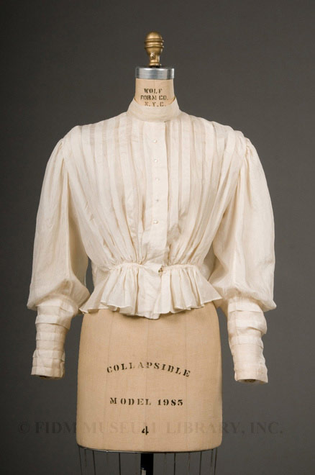

Tortora, P. G., & Eubank, K. (2010). *Survey of historic costume: A history of western dress*. Fairchild.

<https://fashionhistory.fitnyc.edu/shirtwaist/>

<https://trulyvictorian.info/index.php/product/tv494-1894-shirtwaists/>

1. Tailor-made costume
2. Tea gown- Savannah Tanner
   1. Tea gowns popped into popularity in the 1870’s. These dresses were worn without a corset and were meant to be loose. They had a softer silhouette than daytime and evening gowns. One would wear a tea gown when socializing with other ladies in one’s own home. If one were to plan on dining after tea time they would need to change if they planned to eat anywhere besides their own home. These dresses appealed to the middle class, where one could pretend to put on an air of refinement whilst socializing.
   2. 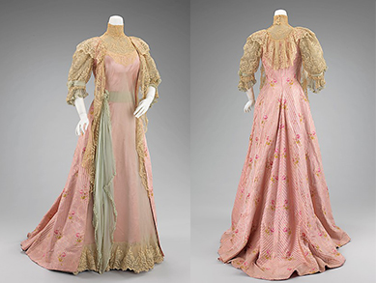
   3. Pg 387
   4. https://recollections.biz/blog/tea-gown-bridging-victorian-edwardian-fashion
   5. https://fashion-history.lovetoknow.com/clothing-types-styles/tea-gown
3. Top
4. Tuxedo - jamie rakes 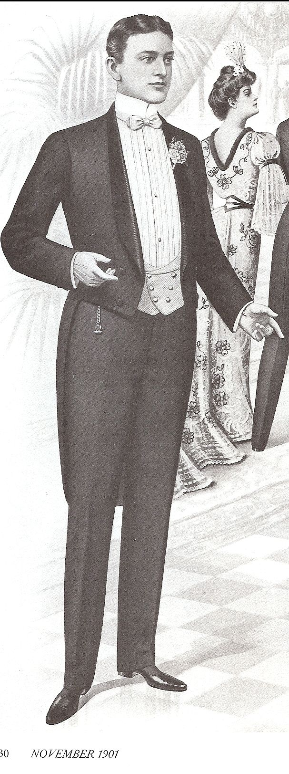

Was a dress version of the sack suit. It was called a tuxedo suit because it was made in/originated in tuxedo New York. However in England it was called the dinner jacket. It was also a short jacket without tails that were typically black and worn with a bow tie.

<https://quizlet.com/104651051/key-terminology-1870-1900-flash-cards/>

<https://books.google.com/books?id=68ZUEAAAQBAJ&pg=PA194&lpg=PA194&dq=1870-1900+tuxedo&source=bl&ots=__q7A6X891&sig=ACfU3U1bdrHSLdjHuShAyPT7_BNxcf1r_Q&hl=en&sa=X&ved=2ahUKEwj4kYfXgqP2AhWKLDQIHXzRBCgQ6AF6BAgdEAI#v=onepage&q=1870-1900%20tuxedo&f=false>

Textbook pg 301

1. Ulster-Marisol Dejesus

A ulster is a long coat with a removable hood or cape. Also it sometimes has a belt. Both women and men use ulster. Their outfits are similar. The word Ulster came from an area called the Irish province of Ulster where people wear a certain overcoat.

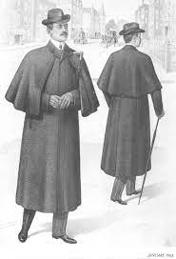

Textbook pg. 392 & 403

<https://en.wikipedia.org/wiki/Ulster_coat#:~:text=The%20Ulster%20is%20a%20Victorian,with%20a%20cape%20and%20sleeves>.

<https://www.gentlemansgazette.com/ulster/>

1. Union suit- Claire Moore

A union suit is a one piece undergarment that was worn by both men and women. At the beginning when women first wore it they were seen as rebellious or “dress reformers”. Eventually men adopted the style because they were seen as comfortable and practical.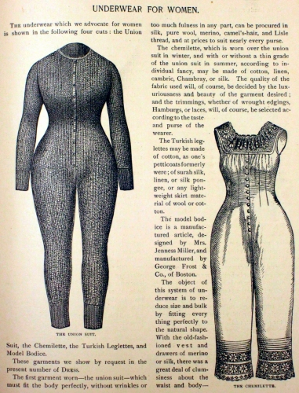

Sources <https://www.smithsonianmag.com/innovation/how-19th-century-activists-ditched-corsets-for-one-piece-long-underwear-180976774/>

<http://www.vam.ac.uk/content/articles/h/history-of-fashion-1840-1900/>

1. 3 styles of bustles & years
2. Bicycling costume- Zaya Weight

In the 1890s cycling was a popular active sport that was acceptable for women to do. Riding a bicycle was done in full skirts but this was difficult & potentially hazardous. One of the ways they dealt with this was knickers/rationals, essentially extremely full trousers that had the appearance of a skirt due to said fullness. Split skirts were also created, often with a front panel of some kind that would hide the split. These two bifurcated garments allowed women to ride bicycles more safely while still staying mostly within acceptable dressing standards. The most common upper body clothing for cycling was shirtwaists, fitted jackets, or sweaters/jumpers. Leg-of-mutton sleeves were by far the most popular style of sleeves.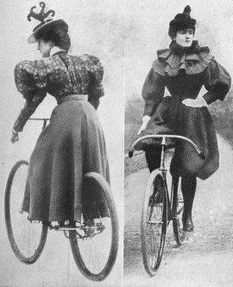

**Sources:**

Survey of Historic Costume

<https://www.theatlantic.com/technology/archive/2018/04/how-cycling-clothing-opened-doors-for-women/558017/>

<https://www.youtube.com/watch?v=hAkYO35yLoI>

1. Aesthetic dress/movement- Ida Johnson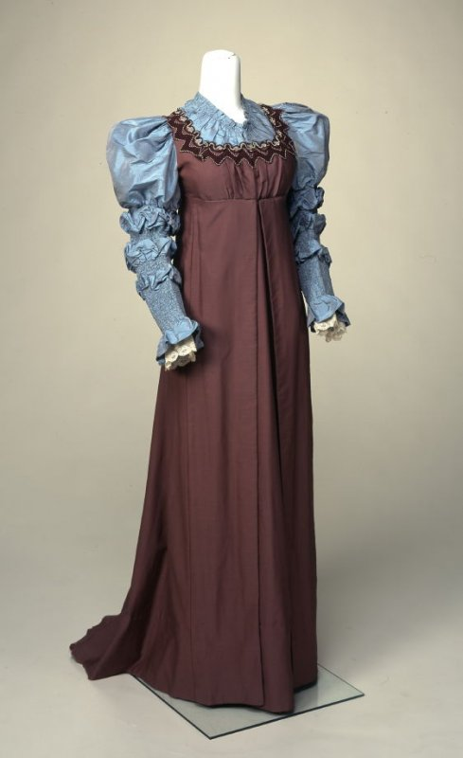

Origin is in the Pre-Raphaelite movement, a group of oppositional painters from the 1840s. A popularized form came about in the 1880s and 1890s and was called the Aesthetic Movement. This movement attracted painters, designers, craftsmen, poets, and writers such as Oscar Wilde. Japanese and Asian influences became more pronounced. The ideal of 'The House Beautiful' sparked a revolution in building and interior decoration and led ultimately to a more widespread recognition of the necessity of beauty in everyday life. This idea would have a lasting impact not only on architecture but also on social theory and political thinking for years to come. Women wore no stays and sometimes no petticoats. Aesthetic wearers looked more comfy and languid, in contrast to the rigid and stiff fashion of the day. A common statement is “Art for Art’s sake”. “Aesthetic dress, a style based on medieval or classical dress, loose in appearance, made from fine soft fabrics in subtle colours, and embroidered in distinctive stylised designs. <https://www.vam.ac.uk/articles/an-introduction-to-the-aesthetic-movement#:~:text=The%20Aesthetic%20Movement%20in%20Britain,'Art%20for%20Art's%20sake>'. <http://www.thejohnbrightcollection.co.uk/costume/tea-gown/> <https://maggiemayfashions.com/calicoball/fashionhistory/the-victorian-era-second-bustle-period-and-aesthetic-dress-1883-1890/> 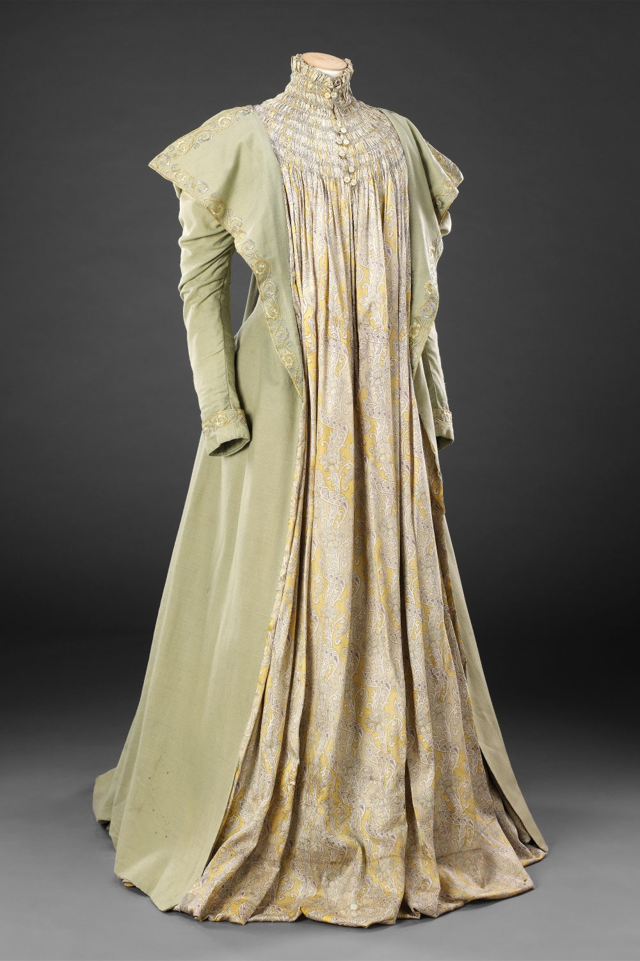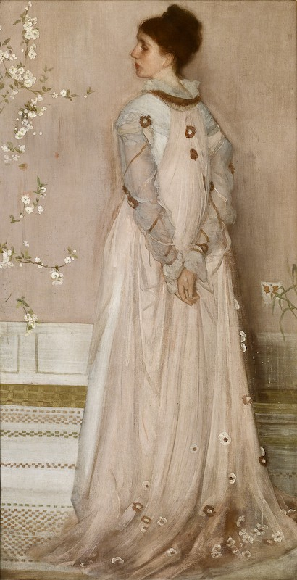

1. Gay Nineties - what was it? - Abby Fluckiger

​​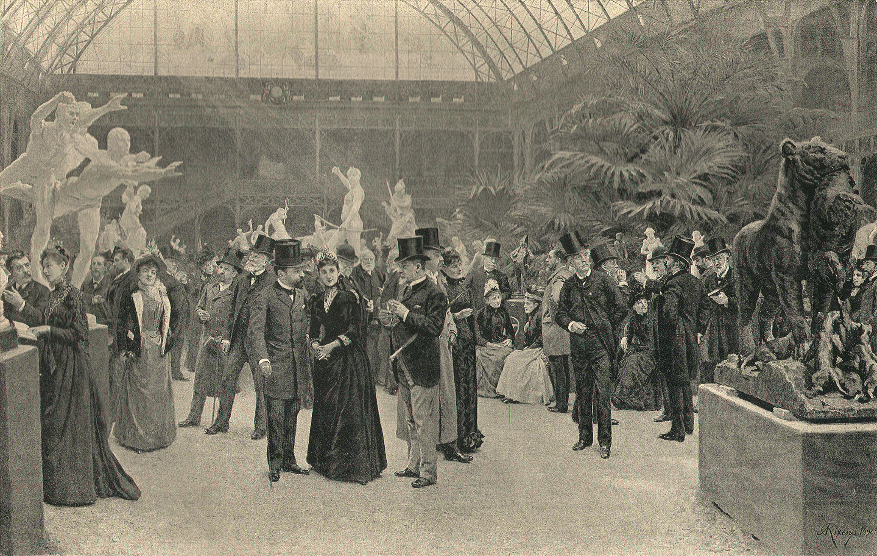

The Gay Nineties was the name given to the 1890s by the US and western Europe, aside from France, where it was called La Belle Époque. The decade was given the name partly because of its emergence from the moralistic, constrained tone of the Victorian Era, into a period of more fanciful art, fashion, and lifestyle, along with the social reform taking place. As the book puts it, this decade had more of a “sense of fun and good humor”, or at least, this is how we look back on it. The name “Gay Nineties” didn’t start circulating until the 1920s.

Sources:

Textbook page 384

<https://en.wikipedia.org/wiki/Gay_Nineties>

<http://www.angelsmyth.com/gay_nineties.html>

1. La Belle Epoque - What was it? -Jalissa Cloward

La Belle Epoque (“the beautiful era”) was a time period in France where people lived in a frivolous and peaceful time. It took place between the Franco-Prussian War and World War I. It was a time of peace where art and technology was able to grow and advance. Impressionism appeared and started to flourish with artists like Monet. 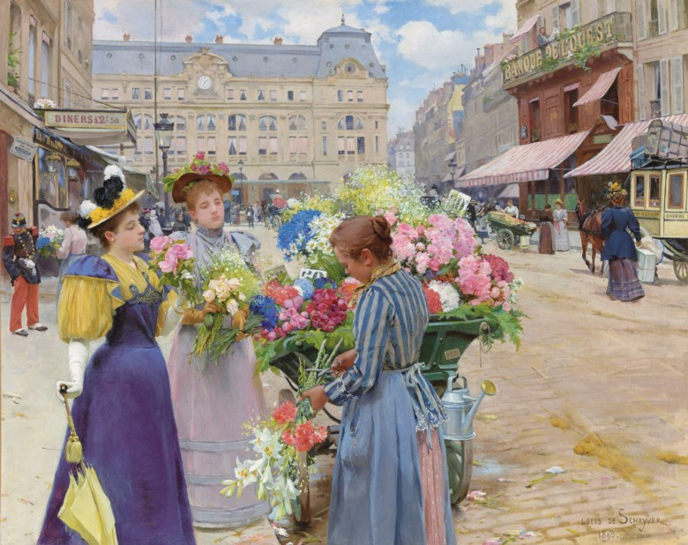

*Survey of Historic Costume* pg. 379

<https://my.wlu.edu/office-of-lifelong-learning/alumni-college/la-belle-epoque>

<https://www.mdc.edu/wolfson/academic/artsletters/art_philosophy/humanities/belleepoque.htm>